**Auto Marking Program Guideline**

**Things to do for Web Client**

1. You have to handle message received from Auto marking Web server.
2. Know how to handle Restful methods. We will handle **Get, Post** and http client header.
3. (Optional) GUI for Web Client. You can build with MFC, Java Swing, HTML and etc.

**List of grading items**

1. Mission1 : Handle USER-AGENT in HTTP Request header
   1. Format : Student Number/Name/ Program name/ Subject
   2. e.g. 2017102889/HYUNJINPARK/WEBCLIENT/COMPUTERNETWORK
2. Mission2 : GET/POST Method Request
   1. You need to implement ‘GET’ method and send request to Automarking server that you assigned URL then you will receive pictures
   2. Send POST request with how many picture you receive on payload (e.g. 4). http://166.104.143.225:*Assigned Port(See 3)*/test/picResult
3. Mission3: POST Method
   1. Send Post request to http://166.104.143.225:*Assigned Port*/test/postHandleTest
   2. You will receive number on response. Select what you received
4. (Optional) Mission4: GUI
   1. Send get method to the auto marking server that you are assigned and check what you can see. (We blocked to check what picture you received with commercial browser)
   2. If you want to check what picture you received, you have to build your client with GUI
   3. This is not essential missions. If you settle down this mission, you MUST include GUI source code; otherwise, this score is not recognized.
   4. Even if you are not able to resolve this mission, there is no minus point.

**How to test?**

* + 1. Approach *166.104.143.225/index* through your web browser (Internet Explorer, Chrome, Firefox and etc.). Next move to “Computer Network” and click “Go Test”(Student manual is right next to “Go Test”).

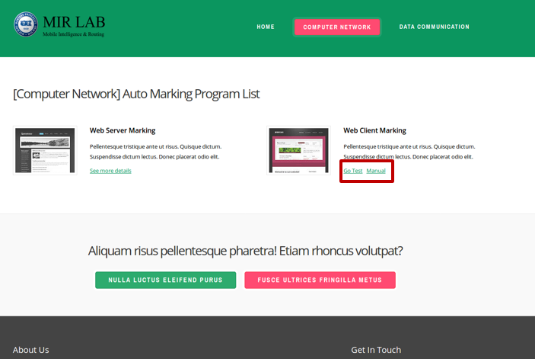

* + 1. Fill in the blanks

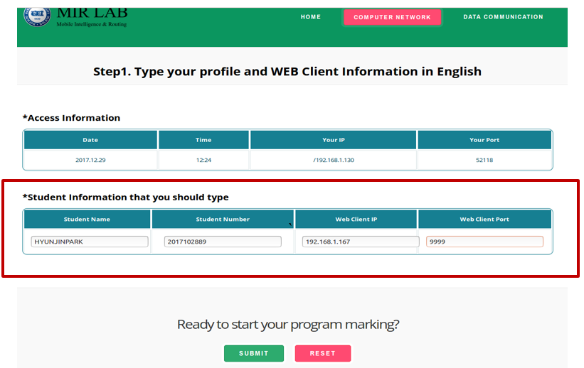

* + - * 1. Student Number(2017xxxxx)
        2. Student Name (Should be written in English)
        3. Your Web Client IP Address and Port. If you are hard to find your global IP, refer to “Your IP” in case you approaches this web site with the same computer
    1. Mission1: Access to the URL that we provide (e.g. <http://192.168.1.126:59724/test/index.html>) by using your Web Client

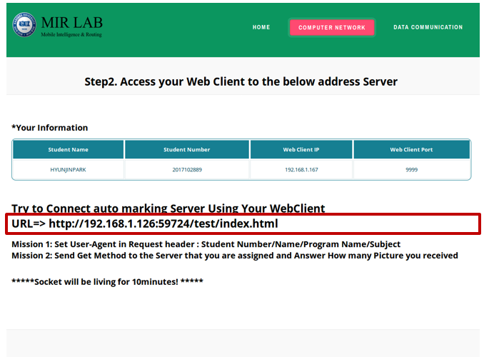

* This socket will be alive for 10minutes. You should meet Mission1, Mission2

1. Mission1: Fix user-agent in http header as Student “Number/Name/Program Name/Subject” (You MUST meet that format without **“”**)
2. Mission2: Send get method to server that you are assigned and answer how many picture you received

* If you get in trouble, 2 main reasons are Firewall problem or you had put Wrong Web Server IP Address or Port Number(**Suggest you to visit ITBT 402-1**)

1. Firewall problem: You have to forward your port through Router. Most routers are available to forward specific port number; however some Router is impossible to forward part because of Telecom policy, in this case visit ITBT/402-1 and test it as local address.
2. Check your Web Server IP address or Port
   * 1. Mission2: Send Get request

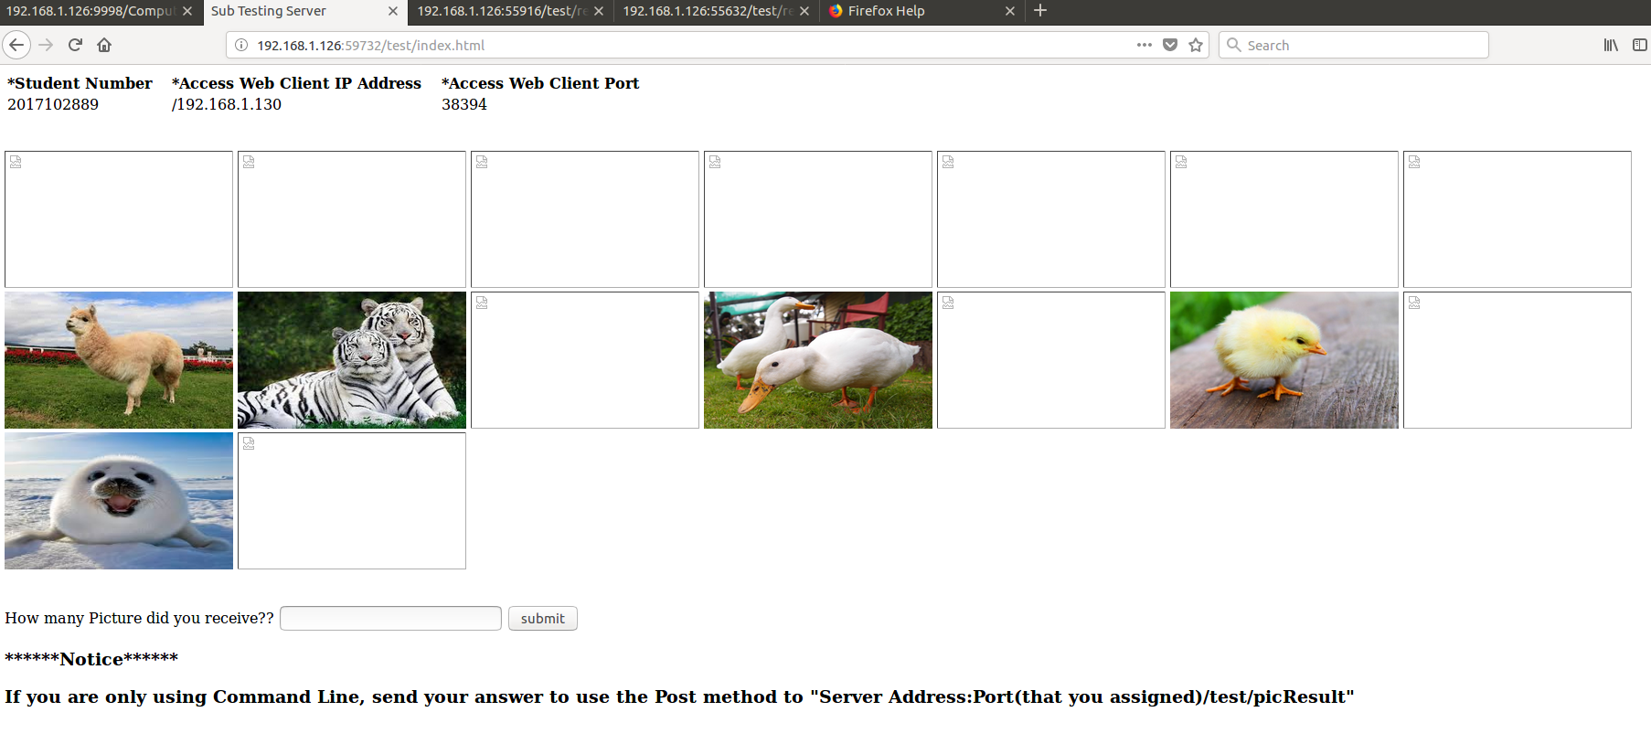

1. That capture is just for helping you to understand easily. **Do not use commercial browser such as Chrome, Internet Explorer.**
2. After send GET Request, you will get pictures. Send Post Request to Automarking server(166.104.143.225:*Assigned Port(See 3)*/test/picResult
   * 1. Mission 3. Send Post Message

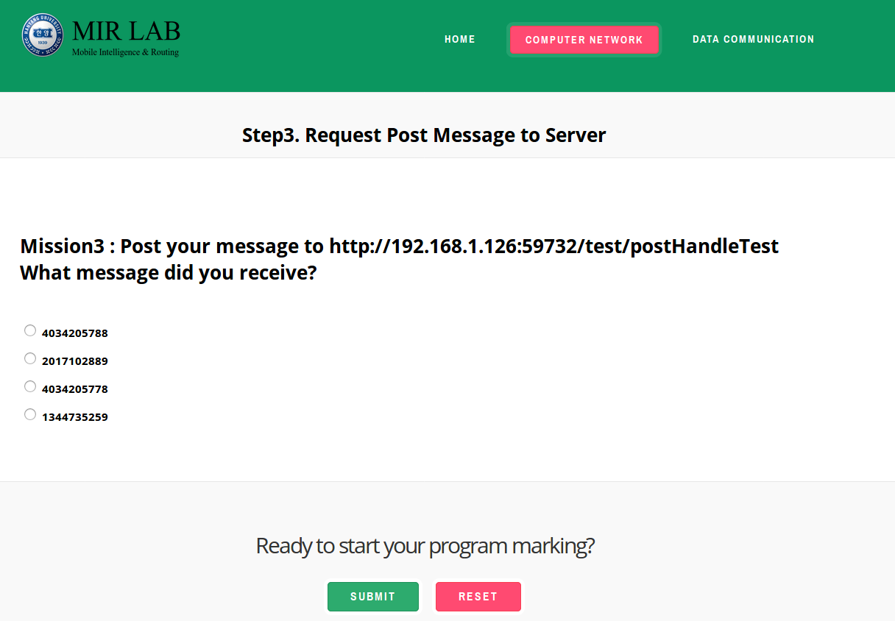

1. Send Post request to http://166.104.143.225:*Assigned Port*/test/postHandleTest
2. You will receive number on response. Select what you received
   * 1. Optional Mission

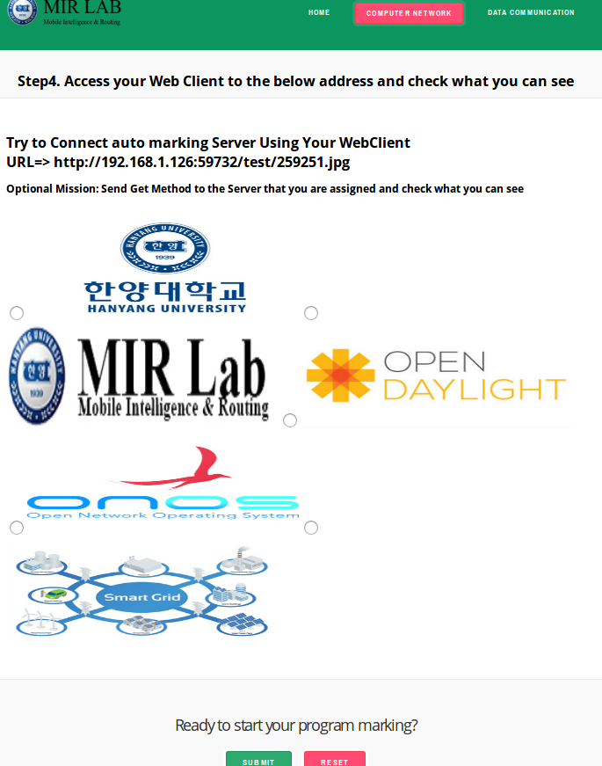

1. Send get method to the auto marking server that you are assigned and check what you can see. (We blocked to check what picture you received with commercial browser)
2. If you want to check what picture you received, you have to build your client with GUI
3. This is not essential missions. If you settle down this mission, you MUST include GUI source code; otherwise, this score is not recognized.
   * 1. Result

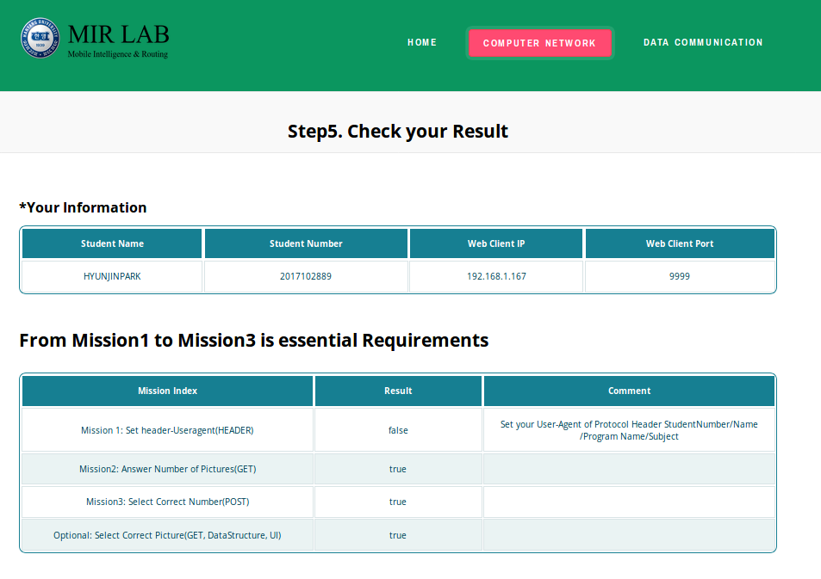

1. Check your result out
2. The recent data is stored our Database. During assigned period, here is no limit trying to check.